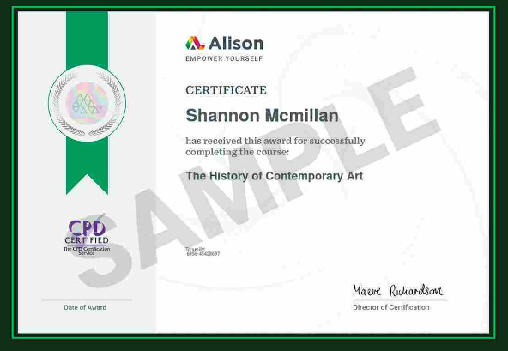
The History of Contemporary Art

Awarded: March 2025
Completed this in-depth course on contemporary art and many art movements from Ancient Egypt to Pop Art and onwards.

(I cannot afford to pay for a non-sample certificate right now. As I am unemployed and plan to complete multiple courses with Alison.)

