**Assess the view that Stalin’s suspicions of his Western allies between 1941 and 1945 were justified.**

**Shannon Mcmillan**

When assessing Stalin’s suspiciousness of the Western powers, we can discuss social, political, and military factors to argue whether Stalin was justified or not. This is an important topic as this was the largest conflict between Capitalism and Communism in 1946. Contextually, since the 1800s there has been tension between the Western Allies and Russia with each side demonising each other. The use of propaganda in the West and Russia, from 1941 to 1945, developed to a positive, pro-alliance media such as Source C[1] from aggressive political enemies when Churchill perceived Soviet Russia to be a “gigantic menace to the peace of Europe.”[2] Both Stalin and the Western allies had suspicions of each other due to diametrically opposing opinions of capitalism and communism, this contributed to the tensions within the Grand Alliance between 1941 and 1945. The Grand Alliance was only created out of convenience to defeat the common enemy of Nazi Germany, and Historian Scott Harrison argues that the alliance between the USSR and the West was liable to collapse in 1945, once their common goal was achieved. While Historian Mike Sewell opposes this arguing that this alliance created a stronger bond which had the potential to develop into a long-term alliance. Authority over Poland, from 1943 to 1945, also contributed to the tension and mistrust between USA and Britain with the USSR and may have contributed to the establishment of the Second Front. Historian James Fitzgerald argues that the independence of post-war Poland was undermined by decisions taken at the Teheran Conference in November 1943. Another factor of the European powers and the USSR was the Second Front in June 1944, Historian Bradley Lightbody argues that the Soviet Union expected that the Western Allies delayed the Second Front to create battles between the USSR and Nazi soldiers. Suggesting this would aid the West in eliminating pre-war threats of Communism with Stalin and Fascism with Hitler, therefore one could argue that the Second Front would justify Stalin’s suspicions of his Western allies. Historian Robert Wilson argues that the complex preparations for the D-Day landings created a necessity for the Second Front, this interpretation suggests that this was necessary to defeat Nazi Germany. These factors during their Grand Alliance contributed to Stalin’s suspicions of the West.

Social factors of the Cold War could be argued as the most influential component of Stalin’s suspicions of his Western allies between 1941 and 1945. The Grand Alliance was a military alliance of the three major Allies during World War Two: The Soviet Union, the United States, and the United Kingdom. This alliance was created to fight against the Axis powers of Germany, Italy, and Imperial Japan as they threatened the British Empire in North Africa and Asia as well as the British mainland. The main element of the social differences between the USA and the USSR is their differences in ideology with Capitalism and Communism, this pre-existed the Grand Alliance and remained a major factor in world politics after 1945 with the defeat of the Führer. Historians such as Scott Harrison argues that the alliance between the USSR and the West was liable to collapse in 1945. The Western powers purposely affect the relationships within the USSR as the alliance was only out of convenience to defeat the common enemy of Nazi Germany, suggesting Stalin’s suspicions were justified. While Historian Mike Sewell argues that the alliance created a stronger bond which had the potential to develop into a long-term alliance, as “Roosevelt remained confident that he could deal with Stalin in the basis of the mutual trust that had been built up during the war.”[3] Source B[4] reinforces the argument that this alliance’s ultimate goal was the destruction of Nazi Germany rather than forming a strong long-lasting alliance between the Allies and the USSR. The Western Allies feared the expansion of Communism which is reinforced by Churchill’s perspective in 1931 “gigantic menace to the peace of Europe.”, these pre-existing beliefs of Russia and Communism as a whole could be argued to justify Stalin’s suspicions due to years of conflict and controversy since the October Revolution, as the West had convinced Stalin that their main goal was to eradicate the communist system of the Soviet Union, between the West and Russia, then the USSR. On the other hand, one could argue that Stalin was overly cautious of his newfound allies as the Western Allies’ goal was simple. To defeat the fascist leader of Nazi Germany, Adolf Hitler seen which is supported by Source B, and not at all to destroy the communist system of Russia during their alliance.

Another social factor which could have contributed to Stalin’s suspicions is the debate over Poland between 1943 and 1945. Historian James Fitzgerald argues that the independence of post-war Poland was undermined by decisions taken at the Teheran Conference, nicknamed “Eureka”, in November 1943. This conference was a strategy meeting between the “Big Three” - Churchill, Roosevelt, and Stalin – discussing territory. Stalin argued for a revision of Poland’s eastern border with the Soviet Union to mirror the line set by British Foreign Secretary Lord Curzon in 1920, which Churchill disagreed with and declared that “I have not the slightest intention of being cheated over Poland, not even if we go to the verge of war with Russia”[5] two years later, nearing the end of their Grand Alliance. The Western Allies made a situation that no independent Polish government could accept and ensured that a puppet government would have to be installed as a result of agreeing to the Molotov-Ribbentrop Polish boundary in the East.

Political factors of Stalin’s suspicions during the Cold War, Source E[6] by E. H. Shepard displays the three leaders, Prime Minister Winston Churchill, President Franklin D. Roosevelt, and General Secretary Josef V. Stalin standing over the world map, discussing territory which is supported by Source D[7], written by Churchill confirming the division of territory between the Prime Minister, the President, and the General Secretary.

# Bibliography

Source C: A soviet poster produced in 1944; the caption was a quotation from Stalin from 1941, “The Red Army, together with the armies of our allies will break the back of the Fascist beast.” (Poster promoting the Anglo-American-Soviet alliance, colour lithio)

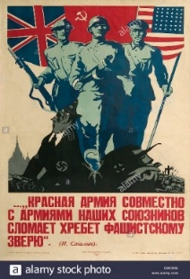

Churchill on 23rd August 1931

James Fitzgerald in *The Cold War and Beyond (1989)*

Source B: A carton by the American children’s writer Dr Seuss, published in 1941. Captioned “They’re serving Roast Adolf at Joe’s House tonight.” (University of California San Diego, Punch Cartoon Library)

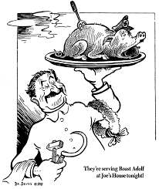

Churchill on the 28th February 1945

Source E: A British cartoon by E. H. Shepard for the satirical magazine *Punch,* published in 1945. Entitled ‘Trouble with some of the pieces’ (E. H. Shephard/Punch Cartoon Library)

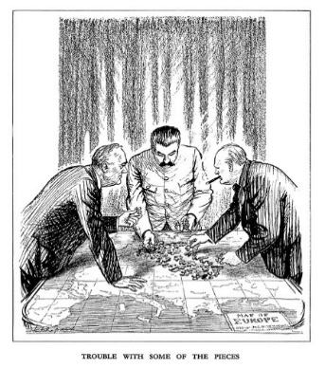

Source D: The ‘percentages agreement’, written by Winston Churchill and the actual document features checkmarks allegedly made by Stalin as a sign of agreement on the 9th October 1944

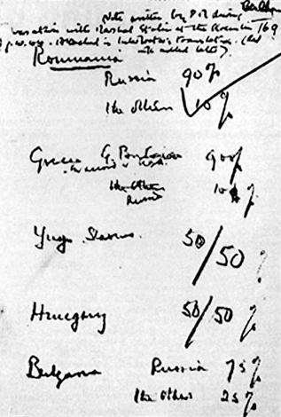

1. Source C: A soviet poster produced in 1944; the caption was a quotation from Stalin from 1941, “The Red Army, together with the armies of our allies will break the back of the Fascist beast.” (Poster promoting the Anglo-American-Soviet alliance, colour lithio)
2. Churchill on 23rd August 1931
3. James Fitzgerald in *The Cold War and Beyond (1989)*
4. Source B: A carton by the American children’s writer Dr Seuss, published in 1941. Captioned “They’re serving Roast Adolf at Joe’s House tonight.” (University of California San Diego, Punch Cartoon Library)
5. Churchill on the 28th February 1945
6. Source E: A British cartoon by E. H. Shepard for the satirical magazine *Punch,* published in 1945. Entitled ‘Trouble with some of the pieces’ (E. H. Shephard/Punch Cartoon Library)
7. Source D: The ‘percentages agreement’, written by Winston Churchill and the actual document features checkmarks allegedly made by Stalin as a sign of agreement on the 9th October 1944