Medieval History: Art and Architecture

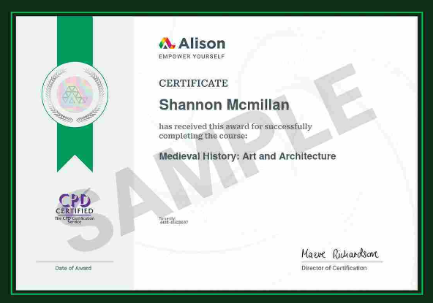
Awarded: April 2025
Completed an in-depth course on Medieval History, exploring topics such as the timeline of the Middle Ages, Kings and Vikings, Charlemagne’s Empire, the Byzantine Empire, Judaism, Christianity, Islam, women and Queens, science and superstition, as well as medieval art, architecture, literature, food, and fashion.

(I cannot afford to pay for a non-sample certificate right now. As I am unemployed and plan to complete multiple courses with Alison.)

